**Supporting Information**

**Simultaneous positive and negative selection of proteases in bacterium based on cell suicide and antibiotic resistance**

**Abeeb Abiodun Yekeen1, Lu Zhang1, Haiyan Liu1,2,3*, Quan Chen1,2\***

1 MOE Key Laboratory for Membraneless Organelles and Cellular Dynamics, Division of Life Sciences and Medicine, University of Science and Technology of China, Hefei, Anhui 230027, China

2 Biomedical Sciences and Health Laboratory of Anhui Province, University of Science and Technology of China, Hefei, Anhui 230027, China

3 School of Data Science, University of Science and Technology of China, Hefei, Anhui 230027, China

**\* Correspondence:** Haiyan Liu (hyliu@ustc.edu.cn), Quan Chen (chenquan@ustc.edu.cn). MOE Key Laboratory for Membraneless Organelles and Cellular Dynamics, Division of Life Sciences and Medicine, University of Science and Technology of China, Hefei, Anhui 230027, China.

**Contents**

Supplementary Methods 4

1. Construction of genetic parts and plasmids 4

2. Growth conditions 5

3. Spot titer 6

4. Combinatorial site-saturation mutagenesis library design and cloning 7

5. Standard plate count and mock selections 8

6. Computational design of TEVp variants and activity test 9

Supplementary Figures 10

Figure S1. Map of the sensor plasmid (SP). 10

Figure S2. Trapping β-lactamase in the cytoplasm using a bulky domain and a cargo size-limited signal sequence. 11

Figure S3. Toxicity assessment of gasdermin D N-terminal domain. 12

Figure S4. Map of the protease expression plasmid (PEP). 13

Figure S5. Proof-of-concept experiments for the PASCAR method 14

Figure S6. Key interactions at the S1 and S3 substrate-binding pockets of TEV protease 15

Figure S7. Spot titer results showing that wild-type TEVp demonstrated poor activity on the P1-H (ENLYFHS) and P1-R (ENLYFRS) substrates 16

Figure S8. Sequencing electropherogram of pooled library clones after MEGAWHOP cloning. 17

Figure S9. Activity of the evolved protease variants on the wild-type substrates 18

Figure S10. Workflow of the ABACUS and the RosettaDesign approaches for the computational redesign of TEVp substrate specificity 19

Figure S11. Amino acid distributions of ABACUS target site designs for a set of substrates 20

Figure S12. Amino acid distributions of RosettaDesign (fixbb) target site designs for a set of substrates 21

Figure S13. Identification of mutable sites in the TEV protease to reprogram its substrate specificity using ABACUS and RosettaDesign. 22

Figure S14. Experimental activity assessment of redesigned protease variants 23

Figure S15. Response of the negative selection module to varying protease activity 24

Figure S16. Mock selection in solid and liquid media 25

Figure S17. Regulation of negative selection stringency by modulating GSNT toxicity level via inducer concentration 26

Figure S18. Mutations in the gasdermin D N-terminal domain and their reported or predicted influences on gasdermin D 27

Figure S19. Gasdermin D mutants enabled the control of negative selection stringency 28

Figure S20. Assessment of the GSNT mutants (extended, full data for Figure S19) 29

Figure S21. Verification of TEV-PH21 activity on target substrates 30

Figure S22. Activity of redesigned protease variants on wild-type-preferred substrate sequence 31

Figure S23. Assessment of the activity of a designed protease on non-target substrates 32

Figure S24. Assessment of the PASCAR system with other proteases 33

Supplementary Tables 34

Table S1. Materials used in this study and their sources 34

Table S2. Primers used in this study 35

Table S3. Genetic constructs used in this study 36

Table S4. Plasmids used in this study 38

Table S5. *E. coli* strains used in this study 39

Table S6. Mock selection of active protease from a dominant background of inactive variants 40

Table S7. Protease-substrate interactions of the TEVp (C151A) with its co-crystallized peptide substrate (PDB code 1LVB) 41

SI References 42

# Supplementary Methods

## 1. Construction of genetic parts and plasmids

The sensor plasmid (SP) was constructed using the pET-28a (Novagen) as a backbone with the f1 phage-derived origin of replication (ori) removed and unique *Nde*I/*Hind*III sites maintained for sensor insertion. Fusion proteins were constructed and cloned into the SP using overlap extension PCR, recombination, or Gibson assembly. The TEM-1 β-lactamase gene as well as its native signal sequence was PCR-amplified using the pBAD/*Myc*-His A plasmid (Invitrogen) as a template. The LacZ gene was PCR-amplified from the *E. coli* BL21(DE3)genome. DNA sequence of the human gasdermin D was amplified by PCR from the phGSDMD plasmid. The protease expression plasmid (PEP) was constructed on the arabinose-inducible pBAD/*Myc*-His A plasmid backbone. The CloDF13 ori and the aminoglycoside adenylyltransferase gene (aadA), which confers resistance to streptomycin/spectinomycin, were PCR-amplified from the in-house plasmids CE-DP-QUR and MP-QUR, respectively. The backbone was modified to carry the spectinomycin resistance marker (aadA) and the CloDF13 ori both replacing, respectively, the original ampicillin resistance and pBR322 ori to ensure compatibility with the SP. The components were assembled using standard homologous recombination reaction. The PEP was engineered to contain the *Nde*I/*Xho*I sites via which protease variants were cloned.

## 2. Growth conditions

Cells were routinely grown in standard LB media (1 % w/v tryptone, 1 % w/v NaCl, 0.5 % w/v) and incubated at 37 °C. Selection experiments were carried out on LB agar media (LB media plus 1.5 % w/v agar) supplemented with 30 µg/mL kanamycin (Kan), 60 µg/mL spectinomycin (Sp) and 20 µg/mL chloramphenicol (Cm). Non-selective media were supplemented with 40 µg/mL Kan, 80 µg/mL Sp and 30 µg/mL Cm. Unless otherwise stated, the PEPand SPwere routinely induced with 0.2 % arabinose and 0.1 mM IPTG, respectively.

## 3. Spot titer

Cells grown overnight were inoculated into (antibiotics-supplemented) LB and cultured for 2-3 hrs until OD600 reached ~0.6. Bacterial growth was halted on ice and cells were collected by centrifugation (4 °C, 5000 rpm, 5 mins). Pelleted cells were re-suspended in 170 mM NaCl whilst adjusting OD600 to ~1.0. Serial 10-fold dilutions were made and for every sample, 2 µL of each dilution were spotted on LB agar plates (supplemented with antibiotics, inducers, and 0.30–0.50 mg/mL carbenicillin). The spots were allowed to dry. Plates were inverted and incubated for 12–16 hours.

## 4. Combinatorial site-saturation mutagenesis library design and cloning

The TEVp used as the starting protease (referred to as wild-type in this study for simplicity) was the solubility- and stability-enhanced L56V/S135G/S219V variant.[1,2] The TEVP-H21 in the original study was engineered on an S219P background,[3] while all TEVp variants reported in this study (including TEVP-H21) were based on an S219V starting variant—both S219 mutants prevent self-proteolysis.

For the construction of the site-saturation mutagenesis library, a pair of degenerate primers were designed for the PCR amplification of the TEVp active site regions that encompassed four target residue positions. The forward primer contained two NNK codons corresponding to positions T146 and D148, while the reverse primer contained two NNK codons corresponding to positions H167 and S170. The 103 bp-long library fragments obtained via a standard PCR were then used in a megaprimer PCR to generate the whole PEP using the MEGAWHOP (megaprimer PCR of whole plasmid) protocol,[4] with some modifications. Unlike the 500 ng megaprimer amount recommended in the original protocol, we used 150 ng megaprimer. A two-step PCR program was used in which the annealing step was omitted. We noted that owing to the long length of the megaprimers, they would re-anneal well enough at PCR temperatures above the elongation temperature post-denaturation, making the annealing step dispensable.

## 5. Standard plate count and mock selections

Overnight culture was inoculated into antibiotics-supplemented LB (1:100) and incubated for 2-3 hrs until the OD600 reached ~0.6. Bacterial growth was halted on ice and cells were collected by centrifugation (4 °C, 5000 rpm, 5 mins). Pelleted cells were re-suspended in pre-cooled LB whilst adjusting OD600 to ~1.0. The OD600-adjusted cultures of the various strains were serially diluted with pre-cooled LB up to pre-determined dilution factors. For the plate count assays, aliquots (100–200µL) of the diluted cultures were spread on the appropriate selective and non-selective LB agar plates and incubated for 12–16 hrs. Plates with 30–300 colonies were counted and used for CFU estimation. For mock selections, appropriate volumes of the diluted cultures of the different strains were mixed to achieve the desired mix ratios. Aliquots (100–200 µL) of the mixed cultures were directly plated on selective and non-selective agar plates and then incubated for 12–16 hrs. Clones were randomly picked from plates with well-spaced distinctive colonies and sequenced.

## 6. Computational design of TEVp variants and activity test

The set of TEVp positions allowed to change for redesign have been chosen using the following computational procedure. First, TEVp variants were designed by allowing a set of 68 residues that were within an 8 Å radius of the P1and P3 substrate residues to change into all amino acid identities except Cys. The other positions were fixed to the native residue types but allowed to adopt alternative rotamer conformations. We separately considered the native substrate (ENLYFQS) and four P1P3-modified substrates (ENLFFNS, ENLGFRS, ENLIFHS, and ENLWFTS) as targets at this stage of computational redesign. For each substrate, 1000 new TEVp variant sequences were redesigned and clustered, using CD-Hit,[5] at 100 % sequence identity (or 99 % when the number of unique sequences exceeded 15) to eliminate redundant sequences. The TEVp positions that showed significantly varied residue type compositions among the redesigned sequences targeting different substrates were selected to form the set of positions that were allowed to change away from the native residue types in the second stage of computational redesign. In this second stage, the target substrate was chosen to be ENLIFHS (IH for short).

We applied the above protocol using each of the ABACUS2 and RosettaDesign programs. For designs with RosettaDesign, the starting structure was first optimized with respect to the Rosetta energy function using default all-heavy-atom constraints. Ten relax trajectories were run on the starting structure with the sidechain subjected to 5 cycles of repacking and minimization. The structure with the lowest Rosetta energy was selected as input for the subsequent fixed backbone redesign steps. Based on the spacing of the mutations, selected designs from the second stage were constructed using site-directed mutagenesis with either overlap-extension PCR[6] followed by restriction cloning into the PEPvia *Nde*I/*Xho*I restriction sites, or multiple fragment PCRs followed by standard recombination reaction. *E. coli* cells BL21(DE3)pLysS were transformed with each PEPand the activity of the corresponding design was evaluated using the positive selection of PASCAR. We noted that the designed changes of the residue N44 of the ABACUS2-designed sequences did not appear to be at a key position (in the structure) for substrate recognition and was not implemented in the experimental tests to facilitate rapid plasmid construction.

# Supplementary Figures



Figure S1. Map of the sensor plasmid (SP). The SP encodes a protease specificity sensor that is made up of the survival and suicide modules linked by the positive cleavage site (pcs). The two domains—N- and C-termini—of the suicide module are separated by a negative cleavage site (ncs). Expression of the sensor is under the control of the T7 promoter inducible by IPTG. The SP carries the high copy pBR322 origin of replication and is maintained with kanamycin. Map was generated with SnapGene 3.2.1.[7]



Figure S2. Trapping β-lactamase in the cytoplasm using a bulky domain and a cargo size-limited signal sequence. Cells were spotted on plates with (*right*) and without (*left*) 0.20 mg/mL ampicillin. BLA: β-lactamase, blass: native BLA signal sequence, LacZ: β-galactosidase, tatss: YcbK TAT signal sequence. In all figures showing spot titer results, the 10-1…10-n labels above the plates indicate the (10-fold serial) cell dilution.



Figure S3. Toxicity assessment of gasdermin D N-terminal domain. Toxicity was assessed by comparing the colony-forming capacity of *E. coli* cells via the IPTG-induced expression of GSNT. Plates represent 100-fold dilution of bacterial cultures plated on LB agar media with (*right*) or without (*left*) 0.10 mM IPTG.

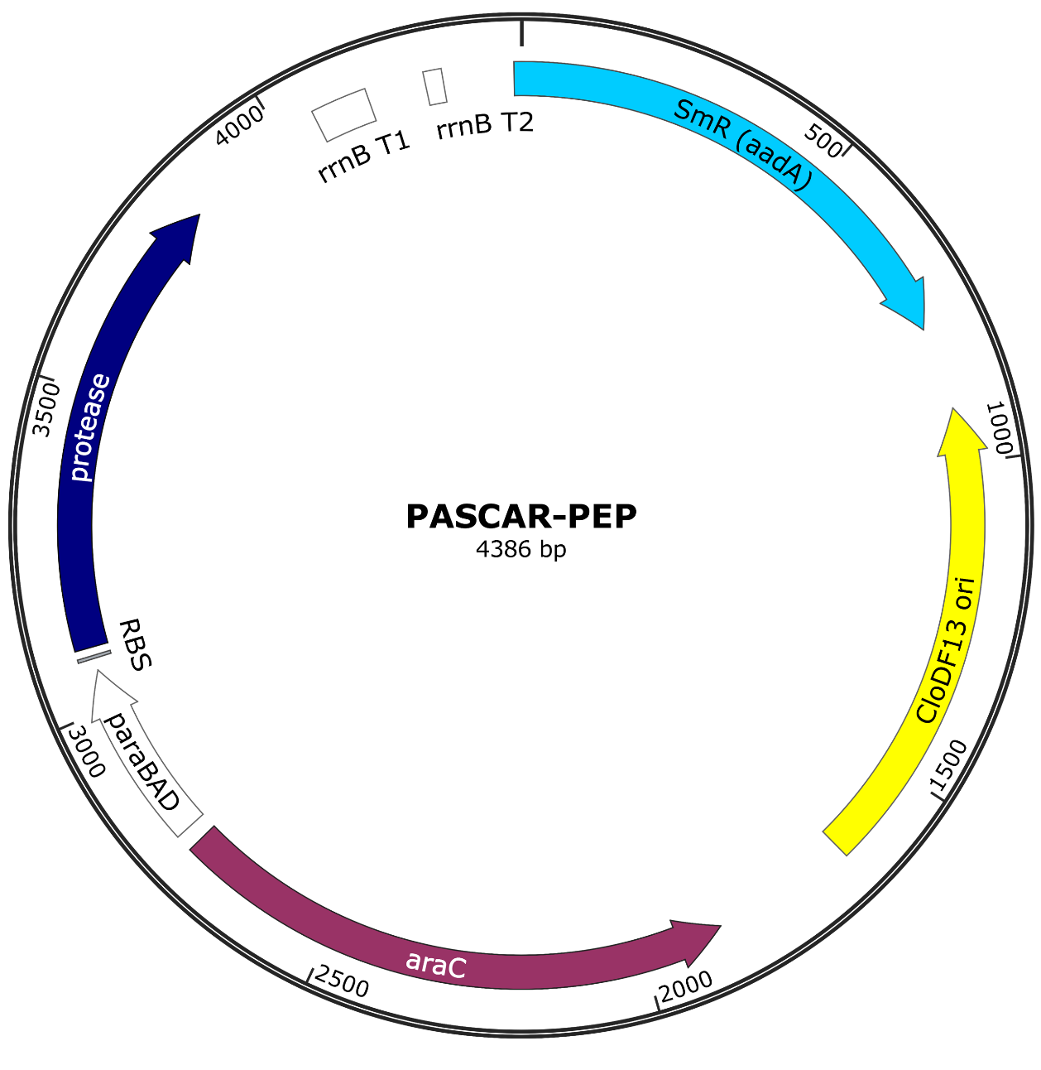

Figure S4. Map of the protease expression plasmid (PEP). The PEP encodes a protease variant whose expression is under the control of the araBAD promoter inducible with arabinose. The PEP carries the low copy CloDF13 origin of replication to ensure compatibility with the SP and is maintained with spectinomycin. Map was generated with SnapGene 3.2.1.[7]



Figure S5. Proof-of-concept experiments for the PASCAR method **(extended data for Figure 1B-E in the main text).** (**A**) Spot titer results showing cytoplasmic trapping of β-lactamase (BLA) via C-terminal fusion of LacZ and via N-terminal fusion of gasdermin D (GS). (**B**) Spot titer results of positive selection. Cells become resistant to β-lactams only when an active protease is expressed with it cognate substrate sequence placed at the positive cleavage site (*left*). A control assay was set up where the media contained no β-lactam antibiotic (*right*). (**C**) Expression of an active protease that recognized the ncs prevented the growth of cells. (**D**) Assay of the protease-responsiveness of the system gave read-outs that corresponded with the expected cell growth/no-growth pattern. In all figures showing spot titer results, the 10-1…10-n labels above the plates indicate the (10-fold serial) cell dilution. The label “*cas_--*” denotes a configuration with only the GS protein that is not fused to BLA (i.e., no positive selection). TEVp: Tobacco Etch virus protease. dTEVp: deactivated TEVp (C151A).



Figure S6. Key interactions at the S1 and S3 substrate-binding pockets of TEV protease. The residues T146, D148, H167, and S170 of the pocket were targeted for mutagenesis. Green, cyan and yellow sticks represent substrate residues, TEVp residues and TEVp catalytic triad, respectively. PDB code 1LVB.



Figure S7. Spot titer results showing that wild-type TEVp demonstrated poor activity on the P1-H (ENLYFHS) and P1-R (ENLYFRS) substrates**.**

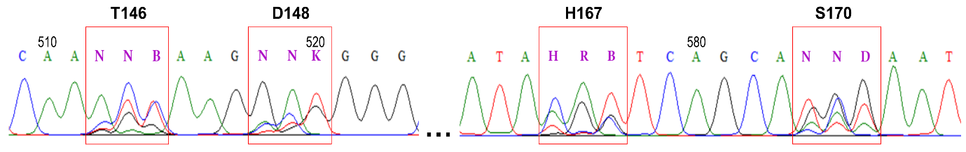

Figure S8. Sequencing electropherogram of pooled library clones after MEGAWHOP cloning. Electropherogram figure was generated using the BioEdit software.[8]



Figure S9. Activity of the evolved protease variants on the wild-type substrates**.** P1-H: ENLYFHS and P1-Q: ENLYFQS. Carbenicillin concentration = 0.35 mg/mL.



Figure S10. Workflow of the ABACUS and the RosettaDesign approaches for the computational redesign of TEVp substrate specificity**.**

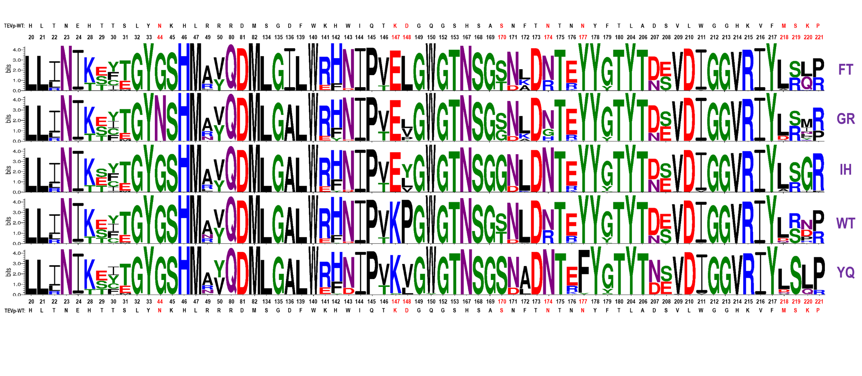

Figure S11. Amino acid distributions of ABACUS target site designs for a set of substrates**.** The P3P1 substrate residues are shown at the far right in purple font. Wild-type residues at the targeted positions are shown above and below the sequence logo with the designation TEVp-WT. Residue positions with obvious varying amino acid types are shown in red font. P3FP1T: ENLFFTS, P3GP1R: ENLGFRS, P3I-P1H: ENLIFHS, P3WP1T: ENLWFTS and P3Y-P1Q: ENLYFQS.



Figure S12. Amino acid distributions of RosettaDesign (fixbb) target site designs for a set of substrates**.** The P1P3 substrate residues are shown at the far right in purple font. Wild-type residues at the targeted positions are shown above and below the sequence logo with the designation TEVp-WT. Residue positions with obvious varying amino acid types are shown in red font.



Figure S13. Identification of mutable sites in the TEV protease to reprogram its substrate specificity using ABACUS and RosettaDesign.Mutable sites predicted via the stage 1 run for each of (**A**) ABACUS and (**B**) RosettaDesign are indicated with the sphere (ball) representation (for clarity, only main chains are shown). The native substrate is colored green, with the targeted P3, P1 positions shown in sticks. TEV protease PDB code: 1LVB.

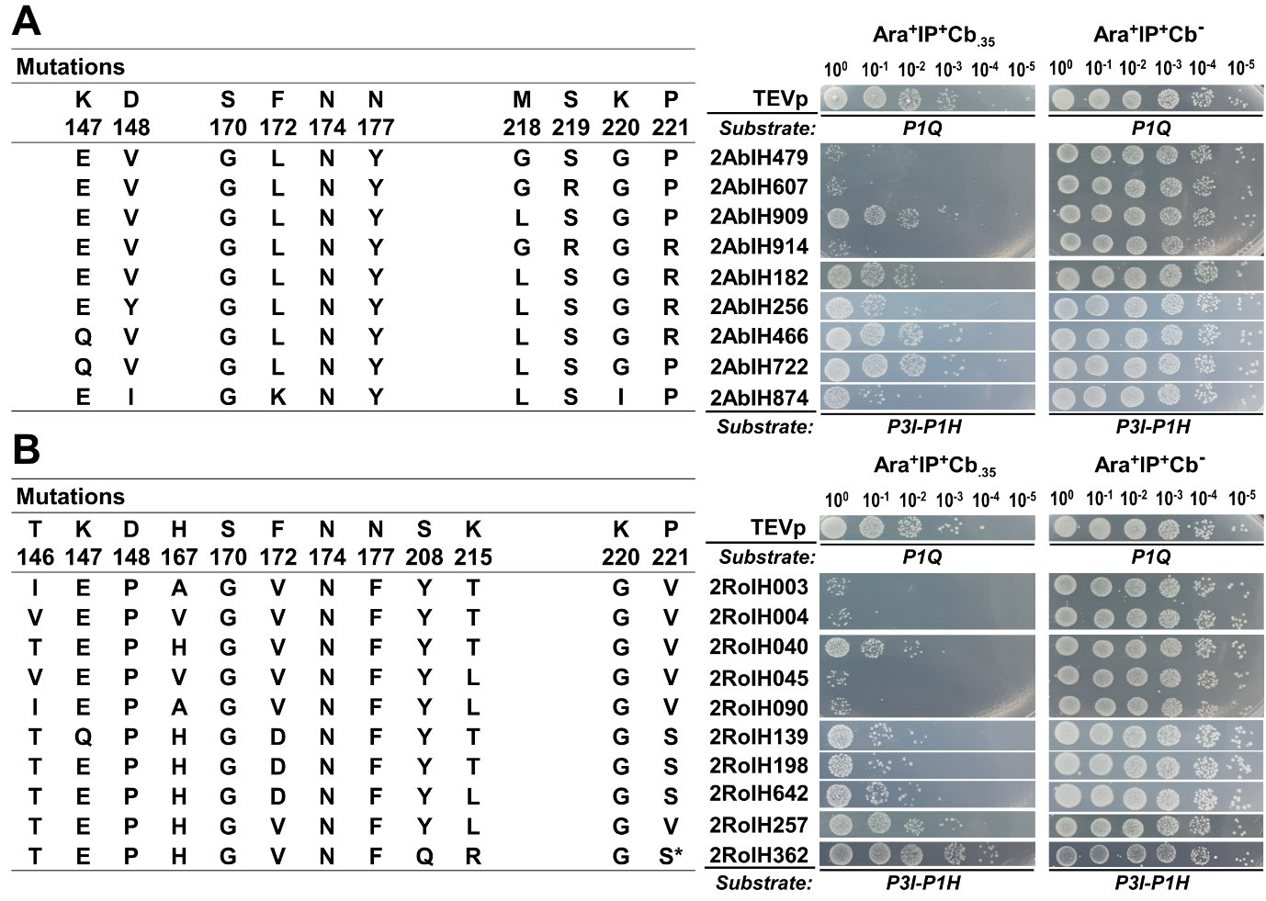

Figure S14. Experimental activity assessment of redesigned protease variants. (A) Redesigned variants obtained with the ABACUS method. (B) Redesigned variants obtained with the RosettaDesign method.



Figure S15. Response of the negative selection module to varying protease activity**.** The assay was carried out in the (**i**) absence and (**ii**) presence of the positive selection pressure i.e., 0.35 mg/mL carbenicillin (Cb.35). The substrates ENLIFHS, ENLYFQS, and the caspase cleavage site (that natively exists within the GSFL domains) are denoted by IH, YQ, and cas, respectively. TEVp: Wild-type Tobacco Etch virus protease. dTEVp: deactivated TEVp (C151A).



Figure S16. Mock selection in solid and liquid media**.** Selection was carried out to assess (**A**) the dual positive-negative selection system, and (**B**) the sole negative selection system. Value above each bar represents the clonal frequency of the corresponding strain in the sequenced population.



Figure S17. Regulation of negative selection stringency by modulating GSNT toxicity level via inducer concentration**.** The ncsand pcswere engineered into the sensor as GSN_ncs_GSC_pcs_BLA, where GSN and GSC denote gasdermin D N- and C-terminal domains, respectively, and BLA denote β-lactamase linked with the TAT signal sequence as a leader peptide. The substrates ENLIFHS, ENLYFQS, and the caspase cleavage site (that natively exists within the GSFL domains) are denoted by IH, YQ, and cas, respectively. TEVp: Wild-type Tobacco Etch virus protease. dTEVp: deactivated TEVp (C151A). mutH3 and mutH5 denote TEVp mutants with full activity on the IH and YQ substrates.



Figure S18. Mutations in the gasdermin D N-terminal domain and their reported or predicted influences on gasdermin D**.** (**A**) Mutations that compromise the lipid- or membrane-binding capacity of GSNT. These class A mutations form part of a conserved Lys/Arg-rich membrane insertion motif and mutations at the residues R138, K146, R152, and R154 have been reported to lower GSNT toxicity in mammalian cells.[9] Mutations in boldface were considered in this study, and those in red font were experimentally tested. The notations *mA*, *mB*, *mC* and *mAB* refer to R138A, K146A, R152A and the double mutant R138A/K146A, respectively. (**B**) Mutations that compromise GSNT oligomerization. (**C**) Mutations that disrupt the autoinhibitory interactions between GSNT and GSCT.

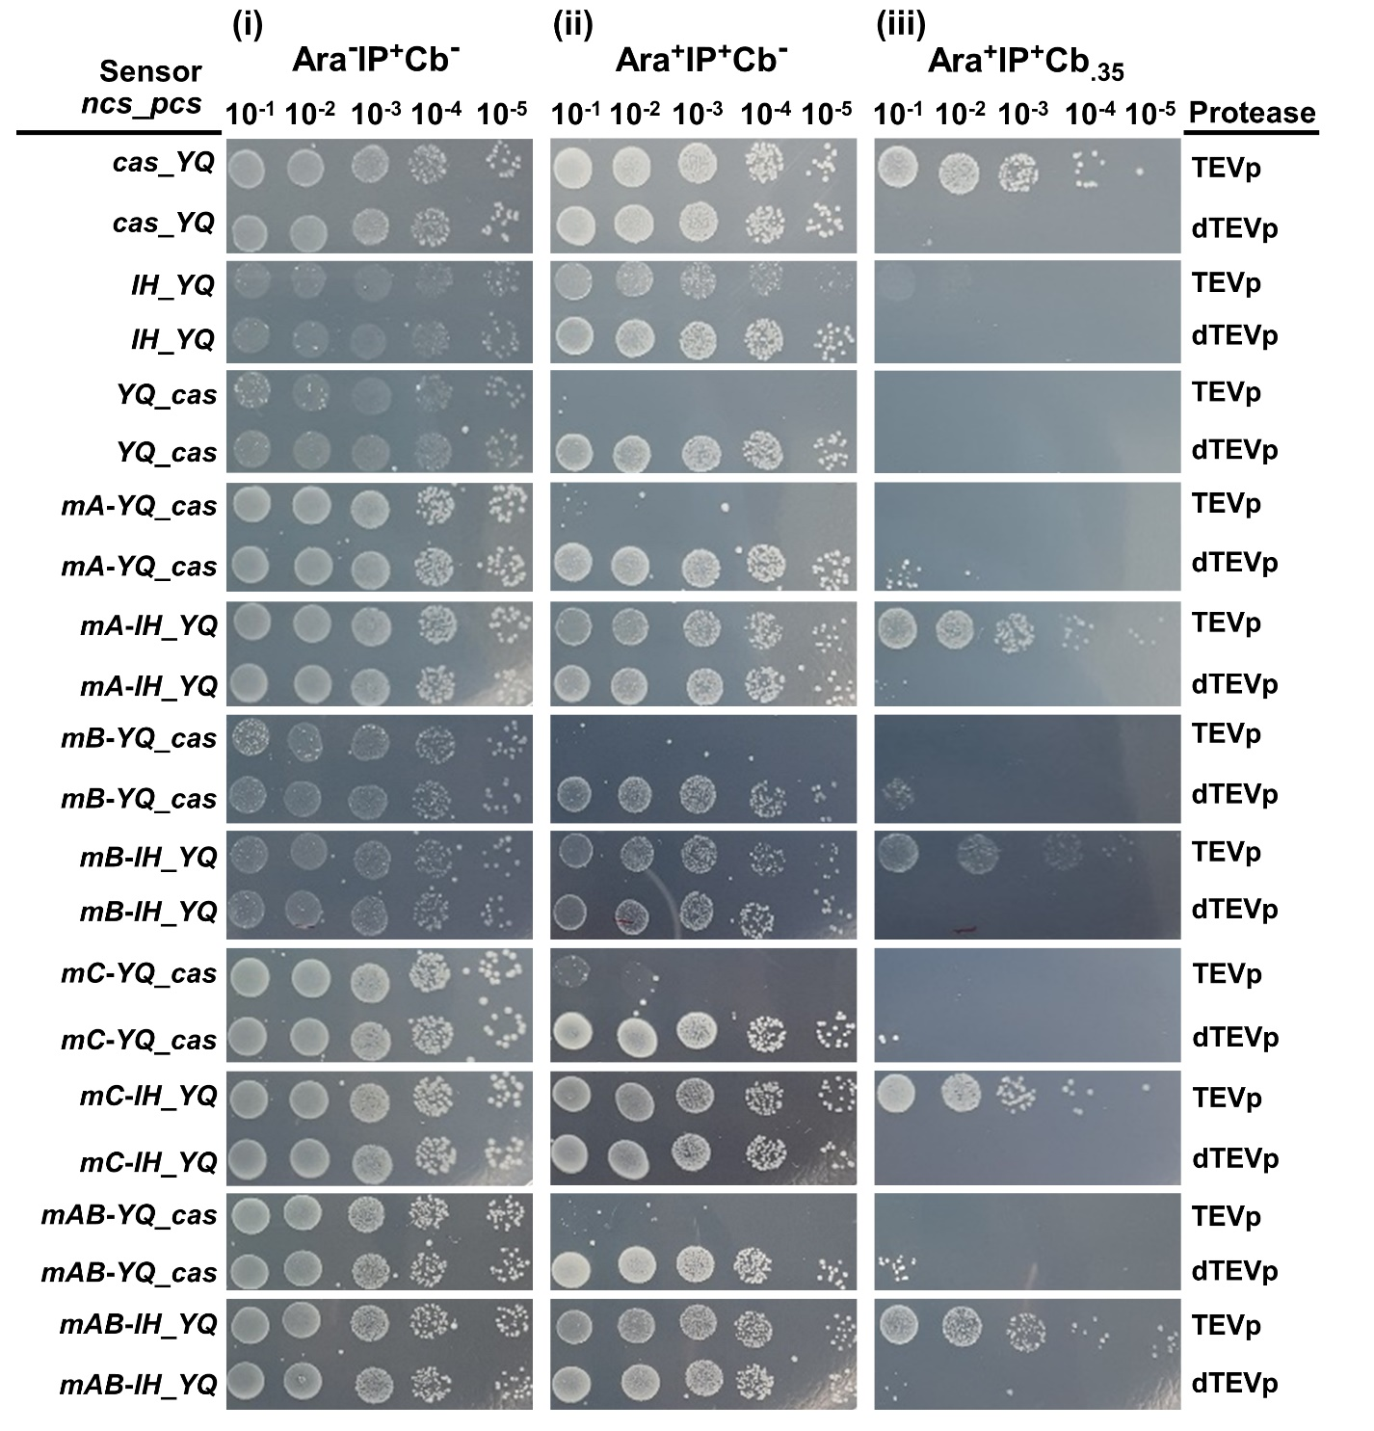

Figure S19. Gasdermin D mutants enabled the control of negative selection stringency**.** Mutants were assessed with (**i**) selection-free, (**ii**) negative selection-only, and (**iii**) dual positive-negative selection assays. The notations *mA*, *mB*, *mC* and *mAB* refer to R138A, K146A, R152A and the double mutant R138A/K146A, respectively. The substrates ENLIFHS, ENLYFQS and the caspase cleavage site (that natively exists within the GS domains) are denoted by IH, YQ and cas, respectively. TEVp: Wild-type TEV protease. dTEVp: deactivated TEVp (C151A).

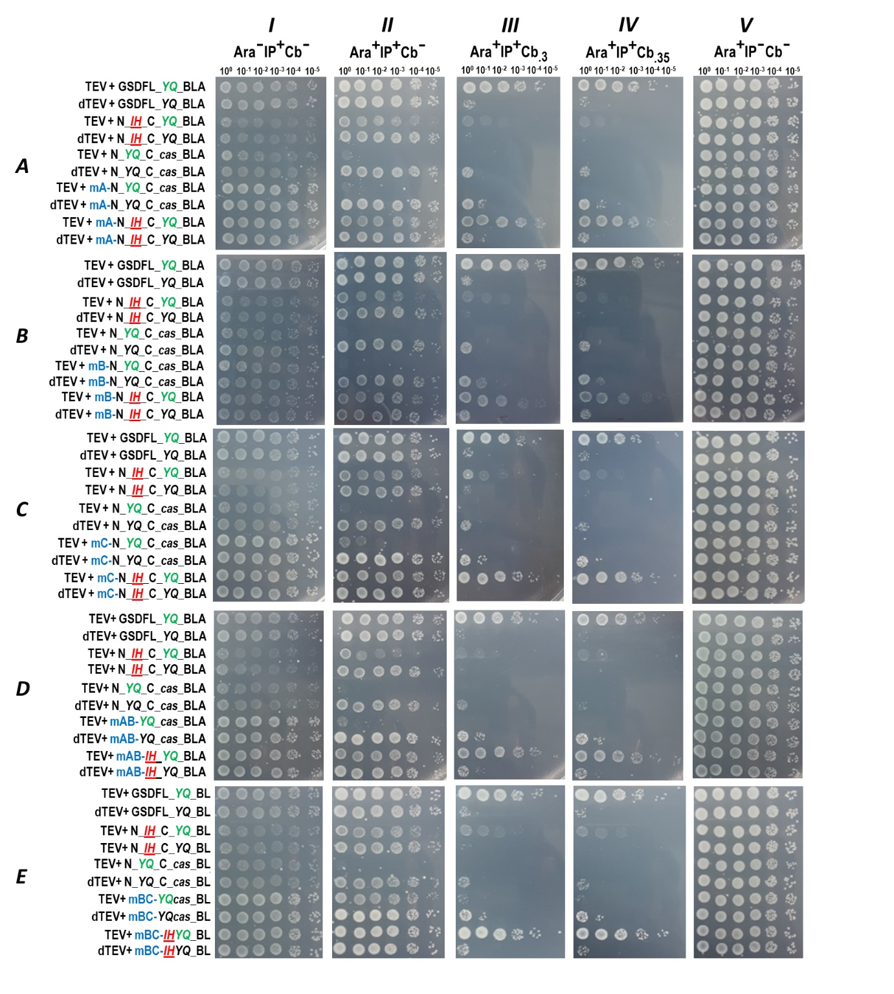

Figure S20. Assessment of the GSNT mutants (extended, full data for Figure S19)**.** Mutants were assessed with (**i**) selection-free, (**ii**) negative selection-only, and (**iii, iv**) dual positive-negative selection assays, as well as (**V**) appropriate controls. The notations (**A**) *mA*, (**B**) *mB*, (**C**) *mC*, (**D**) m*AB*, and (**E**) m*BC* refer to R138A, K146A, R152A, double mutant R138A/K146A, and double mutant K146A/R152A, respectively. The substrates ENLIFHS, ENLYFQS, and the caspase cleavage site (that natively exists within the GSFL domains) are denoted by IH, YQ, and cas, respectively. TEVp: Wild-type Tobacco Etch virus protease. dTEVp: deactivated TEVp (C151A). mutH3 and mutH5 denote TEVp mutants with full activity on the IH and YQ substrates.



Figure S21. Verification of TEV-PH21 activity on target substrates**.**



Figure S22. Activity of redesigned protease variants on wild-type-preferred substrate sequence**.** The nomenclature adopted for the designs follows the format (excluding the hyphenation): **Design stage number-Method-Target P3P1 substrate-Design number**, with “Ab” and “Ro” denoting ABACUS and RosettaDesign, respectively. P3Y-P1Q: ENLYFQS, TEVp: Wild-type Tobacco Etch virus protease, dTEVp: deactivated TEVp (C151A).



Figure S23. Assessment of the activity of a designed protease on non-target substrates**.**



Figure S24. Assessment of the PASCAR system with other proteases**.** Spot assays were done in the presence of (**i**) no positive selection pressure, (**ii**) 0.30 mg/mL carbenicillin, (**iii**) 0.40 mg/mL carbenicillin, and (**iv**) neither the positive selection pressure nor the sensors.

# Supplementary Tables

## Table S1. Materials used in this study and their sources

|  |  |
| --- | --- |
| Materials | Sources |
| Synthetic oligonucleotides | General Biosystems Inc. (Anhui, China) or Sangon Biotech Co. (Shanghai, China) |
| DNA sequences of genetic constructs (codon-optimized) | General Biosystems Inc. (Anhui, China) or Sangon Biotech Co. (Shanghai, China) |
| Restriction endonucleases | Thermo Fisher Scientific Inc. (MA, USA) |
| T4 DNA ligase were from | Thermo Fisher Scientific Inc. (MA, USA) |
| PrimeStar DNA polymerase | TaKaRa, Dalian, China |
| Phusion polymerase | Thermo Fisher |
| DNA gel extraction | Axygen Scientific Inc. (CA, USA) or Promega Corp. (WI, USA) |
| PCR clean up kits | Axygen Scientific Inc. (CA, USA) or Promega Corp. (WI, USA) |
| Multi-fragment recombination kit | Vazyme Biotech Co. (Nanjing, China) |

## Table S2. Primers used in this study

|  |  |  |
| --- | --- | --- |
| Primer | Sequence (5ʹ–3ʹ)a | Target |
| TEVrec-F | gaggaattaa*catatg*GGAGAAAGCTTGTTTAAGGG | TEVp |
| TEVrec-R | tcatg*ctcgag*TTATTGCGAGTAGACTAATTCATTCATGAG | TEVp |
| GSDMD_Nde-F | gaca*catatg*GGGTCGGCCTTTGAGC | GS |
| GSD_GStevs-R | gaagtacaggttttcagaaccgccacctccGTGGGGCTCCTGGCTCAGTCC | GS_tevYQ |
| GSD_casps-R | gagaccccatctgtcaggaagtTAGAACCGCCACCTCCGTGGG | GS_cas |
| pBADRec_SmR-F | ataaccctgataaatgcttcaataatATTGAAAAAGGAAGAGTATGAGGGAAG | aadA |
| pBADRec_SmR-R | cttttctacggggtctgacgctcagtggAACGACATAAGCGGCTATTTAACGACCCTG | aadA |
| SmR_DF-F | TCGTTCCACTGAGCGTCAGACC | CloDF13ori |
| DF_AraC-R | agcttgtctgtaagaggaaCCGTAAAAAGGCCGATCAAAGG | CloDF13ori |
| 138A-F | tctgctccatgaggcgcacctgcggcaGCCAG | mA GS |
| 138A-R | tgccgcaggtgcgcctcatggagcagaGTCTGC | mA GS |
| 146A-F | cagccagaacacgcagtcctgcagcaGCTGCG | mB GS |
| 146A-R | tgctgcaggactgcgtgttctggctgCCGCAG | mB GS |
| 152A-F | tcctgcagcagctggccagccgcggggacaaC | mC GS |
| 152A-R | ttgtccccgcggctggccagctgctgcaggaC | mC GS |
| 1A2A-F | tctgctccatgaggcgcacctgcggcagccagaacacgcagtcctgcagcagCTGCG | mAB GS |
| 1A2A-R | ctgctgcaggactgcgtgttctggctgccgcaggtgcgcctcatggagcagaGTCTG | mAB GS |
| 2A3A-F_new | cagaacacgcagtcctgcagcagctggccagccGCGGGGACAACGTGTACG | mBC GS |
| 2A3A-R_new | ggctggccagctgctgcaggactgcgtgttctgGCTGCCGCAGGTGC | mBC GS |
| Rec_ycbk_bla-F | tgagcaccccgcgtCACCCAGAAACGCTGGTGAAAG | BLA |
| bla_p28bkbn-R | c*aagctt*TTACCAATGCTTAATCAGTGAGGCACCTATC | BLA |

a - Lower case DNA sequences represent recombination site or region outside the target DNA, while italicized sequences represent restriction sites.

## Table S3. Genetic constructs used in this study

|  |  |  |
| --- | --- | --- |
| Name | Sequence | Source/ Reference |
| TEVp |  | [2] |
| GS |  | [10] |
| BLA |  | pBAD/Myc-His A[11] |
| YcbK TATss | atggataaattcgatgcgaaccgtcgtaaactgctggcgctgggcggcgttgcgctgggtgcggcgatcctgccgaccccggcgttcgcgaccctgagcaccccgcgt | [12] |
| BLAss | atgagtattcaacatttccgtgtcgcccttattcccttttttgcggcattttgccttcctgtttttgct | pBAD/Myc-His A[11] |
| TEV-PH21 |  | [3] |
| TEV-PE10 |  | [3] |
| TEVp-mutH2 |  | This study |
| TEVp-mutH3 |  | This study |
| TEVp-mutH5 |  | This study |
| dTEVp (C151A) |  | This study |

## Table S4. Plasmids used in this study

|  |  |  |  |
| --- | --- | --- | --- |
| Code | Name | Relevant Genotype/Purpose | Source/ Reference |
| pET28 | pET28-a(+) | Empty vector, backbone for the sensor plasmid (SP) | [13] |
| pBAD | pBAD/Myc-His A | Empty vector, backbone for the protease expression plasmid (PEP) | [11] |
| SP235 | GSFL_tevYQ_ssBLA_pET28 | IPTG-inducible expression of proteolysis sensor | This study |
| SP386 | GSN_tevYQ_GSC_tevIH_ssBLA_pET28 | IPTG-inducible expression of proteolysis sensor | This study |
| SP493 | 1A2AGSN_tevYQ_GSC_tevIH_ssBLA_pET28 | IPTG-inducible expression of proteolysis sensor | This study |
| SP494 | 3AGSN_tevYQ_GSC_tevIH_ssBLA_pET28 | IPTG-inducible expression of proteolysis sensor | This study |
| SP502 | 1AGSN_tevYQ_GSC_tevIH_ssBLA_pET28 | IPTG-inducible expression of proteolysis sensor | This study |
| SP503 | 2AGSN_tevYQ_GSC_tevIH_ssBLA_pET28 | IPTG-inducible expression of proteolysis sensor | This study |
| SP50 | 2A3AGSN_tevYQ_GSC_tevIH_ssBLA_pET28 | IPTG-inducible expression of proteolysis sensor | This study |
| PEP133 | TEVp_DF13_SmR_pARA | Arabinose-inducible expression of TEVp | This study |
| PEP137 | dTEVp_DF13_SmR_pARA | Arabinose-inducible expression of dTEVp (C151A) | This study |
| PEP289 | TEVp-mutH2_DF13_SmR_pARA | Arabinose-inducible expression of TEVp-mutH2 | This study |
| PEP290 | TEVp-mutH3_DF13_SmR_pARA | Arabinose-inducible expression of TEVp-mutH3 | This study |
| PEP291 | TEVp-mutH5_DF13_SmR_pARA | Arabinose-inducible expression of TEVp-mutH5 | This study |
| PEP521 | TEV-PH21_DF13_SmR_pARA | Arabinose-inducible expression of TEVp | This study |

## Table S5. *E. coli* strains used in this study

|  |  |  |
| --- | --- | --- |
| Strain | Genotype | Purpose |
| TOP10 | *F- mcrA Δ(mrr-hsdRMS-mcrBC) φ80lacZΔM15 ΔlacX74 nupG recA1 araD139 Δ(ara-leu)7697 galE15 galK16 rpsL(StrR) endA1 λ-* | Cloning |
| DH5α | *F– endA glnV44 thi-1 recA1 relA1 gyrA96 deoR nupG purB20 φ80dlacZΔM15 Δ(lacZYA-argF)U169, hsdR17(rK–mK+), λ–* | Cloning |
| BL21(DE3)pLysS | *F– ompT gal dcm lon hsdSB(rB–mB–) λ(DE3[lacI lacUV5-T7p07 ind1 sam7 nin5]) [malB+]K-12(λS) pLysS[T7p20 orip15A](CmR)* | Selection |

## Table S6. Mock selection of active protease from a dominant background of inactive variants

|  |  |  |  |  |  |
| --- | --- | --- | --- | --- | --- |
| **Mixture ratio**  **(TEVp:dTEVp)** | | **Carbenicillin concentration (mg/mL)** | **Percentage in population post-selection (%)a** | | |
| **TEVp** | **dTEVp** |
| **Selection in liquid media** | | |  |  |
| 1:100 | | 0.15 | 100 | 0 |
| 1:1000 | | 0.15 | 100 | 0 |
| 1:100 | **1st hr** | 0.25 | 4 | 96 |
|  | **7th hr** | 0.25 | 100 | 0 |
| **Selection on solid media** | | |  |  |
| 1:100 | | 0.30 | 100 | 0 |
| 1:1000 | | 0.30 | 100 | 0 |

a – Percentages were calculated from clonal frequency based on 25 randomly selected and sequenced clones.

## Table S7. Protease-substrate interactions of the TEVp (C151A) with its co-crystallized peptide substrate (PDB code 1LVB)

|  |  |  |  |  |  |  |  |  |  |
| --- | --- | --- | --- | --- | --- | --- | --- | --- | --- |
|  |  | SUBSTRATE SEQUENCES | | | | | | | INTERACTION |
|  |  | **p6** | **p5** | **p4** | **p3** | **p2** | **p1** | **p1'** |
|  |  | **E** | **N** | **L** | **Y** | **F** | **Q** | **S** |
| POCKET RESIDUES |  | N171 N176 Y178 |  | K215 F217 | D148 S170 N174 | F217 | T146 D148 G149 H167 S168 |  | **Hydrogen bond** |
|  | N176 | F172 F217 | A169 N171 Y178 H214 V216 | V216 K220 | F139 A169 V209 W211 V216 M218 | A169 S170 | T30 L32 | **Hydrophobic** |

# SI References

1. Van Den Berg S., Löfdahl P.-Å., Härd T., & Berglund H. (2006). Improved solubility of tev protease by directed evolution. *Journal of Biotechnology*, *121*(3), 291-298.

2. Kapust R.B., Tözsér J., Fox J.D., Anderson D.E., Cherry S., Copeland T.D., & Waugh D.S. (2001). Tobacco etch virus protease: Mechanism of autolysis and rational design of stable mutants with wild-type catalytic proficiency. *Protein Engineering*, *14*(12), 993-1000.

3. Yi L., Gebhard M.C., Li Q., Taft J.M., Georgiou G., & Iverson B.L. (2013). Engineering of tev protease variants by yeast er sequestration screening (yess) of combinatorial libraries. *Proceedings of the National Academy of Sciences*, *110*(18), 7229-7234.

4. Miyazaki K. (2011). Megawhop cloning: A method of creating random mutagenesis libraries via megaprimer pcr of whole plasmids. *Methods in Enzymology*, *498*, 399-406.

5. Li W., & Godzik A. (2006). Cd-hit: A fast program for clustering and comparing large sets of protein or nucleotide sequences. *Bioinformatics*, *22*(13), 1658-1659.

6. Heckman K.L., & Pease L.R. (2007). Gene splicing and mutagenesis by pcr-driven overlap extension. *Nature Protocols*, *2*(4), 924-932.

7. Biotech G. (2017). Snapgene. *GSL Biotech LLC, Chicago*.

8. Hall T. (1999) Bioedit: A user-friendly biological sequence alignment editor and analysis program for windows 95/98/nt Nucleic Acids Symposium Series.

9. Liu X., Zhang Z., Ruan J., Pan Y., Magupalli V.G., Wu H., & Lieberman J. (2016). Inflammasome-activated gasdermin d causes pyroptosis by forming membrane pores. *Nature*, *535*(7610), 153-158.

10. Strausberg R.L., Feingold E.A., Grouse L.H., Derge J.G., Klausner R.D., Collins F.S., Wagner L., Shenmen C.M., Schuler G.D., Altschul S.F., Zeeberg B., Buetow K.H., Schaefer C.F., Bhat N.K., Hopkins R.F., Jordan H., Moore T., Max S.I., Wang J., Hsieh F., Diatchenko L., Marusina K., Farmer A.A., Rubin G.M., Hong L., Stapleton M., Soares M.B., Bonaldo M.F., Casavant T.L., Scheetz T.E., Brownstein M.J., Usdin T.B., Toshiyuki S., Carninci P., Prange C., Raha S.S., Loquellano N.A., Peters G.J., Abramson R.D., Mullahy S.J., Bosak S.A., McEwan P.J., McKernan K.J., Malek J.A., Gunaratne P.H., Richards S., Worley K.C., Hale S., Garcia A.M., Gay L.J., Hulyk S.W., Villalon D.K., Muzny D.M., Sodergren E.J., Lu X., Gibbs R.A., Fahey J., Helton E., Ketteman M., Madan A., Rodrigues S., Sanchez A., Whiting M., Madan A., Young A.C., Shevchenko Y., Bouffard G.G., Blakesley R.W., Touchman J.W., Green E.D., Dickson M.C., Rodriguez A.C., Grimwood J., Schmutz J., Myers R.M., Butterfield Y.S., Krzywinski M.I., Skalska U., Smailus D.E., Schnerch A., Schein J.E., Jones S.J., & Marra M.A. (2002). Generation and initial analysis of more than 15,000 full-length human and mouse cdna sequences. *Proc Natl Acad Sci U S A*, *99*(26), 16899-16903.

11. Guzman L.M., Belin D., Carson M.J., & Beckwith J. (1995). Tight regulation, modulation, and high-level expression by vectors containing the arabinose pbad promoter. *Journal of Bacteriology*, *177*(14), 4121-4130.

12. Carrico Z.M., Strobel K.L., Atreya M.E., Clark D.S., & Francis M.B. (2016). Simultaneous selection and counter‐selection for the directed evolution of proteases in e coli using a cytoplasmic anchoring strategy. *Biotechnology and Bioengineering*, *113*(6), 1187-1193.

13. Dubendorf J.W., & Studier F.W. (1991). Controlling basal expression in an inducible t7 expression system by blocking the target t7 promoter with lac repressor. *Journal of Molecular Biology*, *219*(1), 45-59.